GAME 1- CHESS
Online Chess Game Experience (Google Chess)
1. Overview
Playing chess online through the official Google chess platform provides a simple and accessible way to enjoy the game. It is designed for both beginners and experienced players, offering a smooth and distraction-free environment.
Figure 1
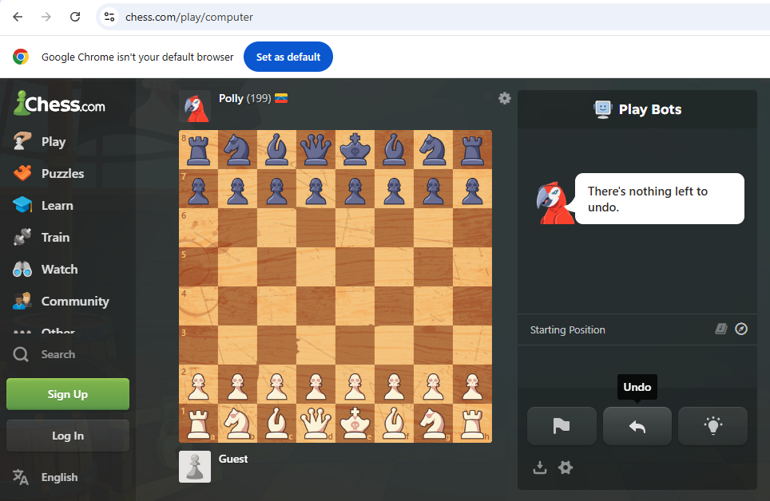

2. Ease of Use
The game is very comfortable and easy to play. The interface is clean, with clearly visible pieces and board layout. Users can start playing instantly without needing to download or install any software, making it highly convenient.

3. User Interface & Design
- The board is visually appealing with well-defined squares and pieces
- Minimalistic design helps players focus on the game
- Smooth animations enhance the overall experience
Figure 2
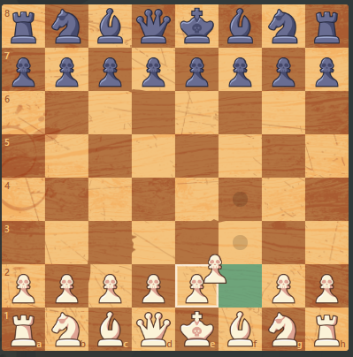
4. Key Features
Drag and Drop Functionality
One of the most useful features is the drag-and-drop system. Players can simply click and drag a piece to its desired position, making gameplay intuitive and natural.
Move Assistance
The game often highlights possible moves when a piece is selected, which is especially helpful for beginners learning the rules.
Undo Option
Players can undo moves easily, allowing them to correct mistakes and learn from them.
Game Modes
- Play against the computer (AI)
- Adjustable difficulty levels for different skill levels

5. Accessibility
- No account required to start playing
- Works directly in a web browser
- Can be accessed on both desktop and mobile devices

To Cap it all
the Google online chess game offers a user-friendly and enjoyable experience. Its simple controls, especially the drag-and-drop feature, combined with helpful tools and accessibility, make it an excellent choice for students and casual players.

GAME 2 – CARDS (SPIDER SOLITAIRE)
Spider Solitaire Game User Experience (UX)
1. Overview
Spider Solitaire is a digital card game that offers a simple, relaxing, and engaging experience. It is designed to replicate the traditional card game while making it more accessible through an intuitive and user-friendly interface.
Figure 3
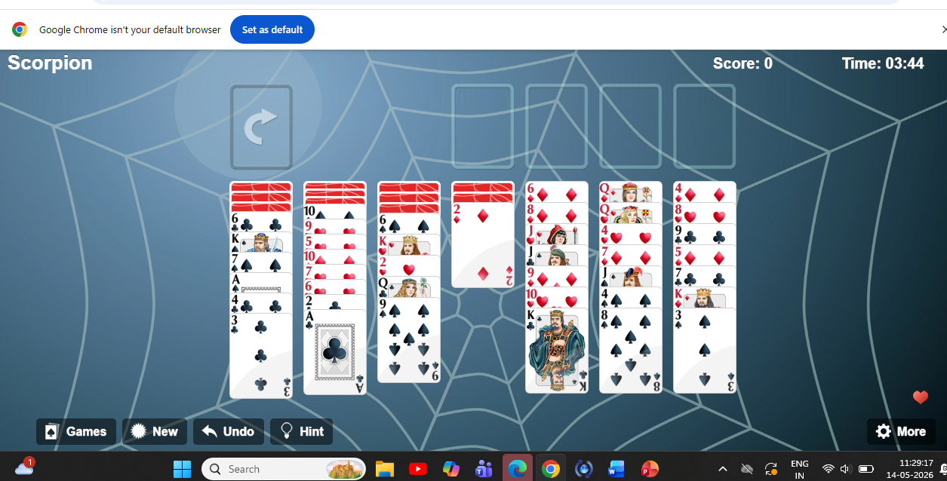

2. Ease of Use
The game is very comfortable and easy to play. Players can quickly understand the rules and start playing without any instructions. The interface is straightforward, allowing smooth interaction with minimal effort.

3. User Interface & Design
- Clean and organized layout with clearly arranged cards
- Traditional green background that resembles a real card table
- Visually distinct cards with readable numbers and suits
- Smooth animations when moving or stacking cards
Figure 4
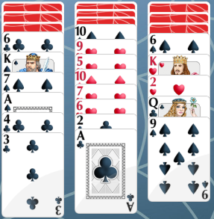

4. Key Features
Drag and Drop Functionality
Players can easily move cards by dragging and dropping them across columns. This makes the interaction natural and improves gameplay speed.
Hint System
The game provides hints to guide players when they are unsure about the next move, improving the overall user experience.
Undo Option
Users can undo moves, allowing them to fix mistakes and try different strategies without restarting the game.
Difficulty Levels
- Single suit (easy)
- Two suits (medium)
- Four suits (hard)
This allows players to choose based on their skill level.
5. Accessibility
- Available directly in web browsers without installation
- Can be played on desktop, tablet, and mobile devices
- Simple controls suitable for all age groups

TO CAP IT ALL
Spider Solitaire provides a smooth and enjoyable user experience. Its clean design, easy controls like drag-and-drop, and helpful features such as hints and undo options make it both relaxing and engaging for players.

